**CC01 – PRODUCT ITEM DETAILS**

**Description**

**Instruction:**

1.if you are using TLAB**, Sample compile and run JCL is available in "TLABADM.LAB.SYS.COMPRUN". Please go in view mode and copy the members to your deliverable dataset.

2. if you are using TLAB**,the IP address  is 10.142.149.210 and the Port is 623 to connect to Mainframe Terminal

**Please do not EVALUATE and just SUBMIT the code for Evaluation  - CC/MOCK/ICT assessments.**

**Objective:**

 Create a COBOL application to maintain PRODUCT ITEM DETAILS

**1.**Create a PDS with the following parameters given below.

NOTE: **USERID**must be your Mainframe ID.

1.   **Using SPUFI**

-         Create a member DB2CC1SC and write SQL to create and load the below tables using SPUFI

**NOTE: DO NOT INCLUDE DROP AND CREATE INDEX STATEMENT IN YOUR SQL CODE.**

**PRODUCT_ITEM TABLE**

**INVOICE TABLE**

3.**OUTPUT LAYOUT :**  
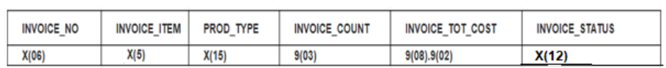

4.     Using above input and output information, write a COBOL program to achieve it.

* The output file should have all the records from the table and sorted based on INVOICE.
* The status of the INVOICE need  to be in CANCELLED state if there is no valid ITEM_TYPE
* The INVOICE status will be 'NO STOCK'  if status of ITEM is 'NO'
* IF ITEM_STATUS is 'YES', please perform below action

a.     If INVOICE_COUNT is greater than ITEM_COUNT, then INVOICE status will be 'OUT OF STOCK'

b.    If INVOICE_COUNT is less than ITEM_COUNT, then INVOICE status will be 'ACCEPTED'

c.     If invoice status is accepted, please calculate the INVOICE_TOT_COST as INVOICE_COUNT * ITEM_PRICE.

5.    The table need to be updated according to each INVOICE and also write all the invoices to the output PS file        USERID.DB2.CC01.OUTPUT.PS1 and the DDNAME is OUTINV

6.    Declare the necessary input and output variables as per the coding standards.

7.    Please follow coding Standards and paragraph should be written in order.

8.    Verify and confirm the output using SPUFI.

Evaluation Procedure:

1)    Use your JCL to pre compile and run and test your program with the necessary inputs and make sure you get the return code MAXCC 00 before Submitting for the Evaluation.

2)    Download your dataset (USERID.MYLIB.DB2.CC01 (DB2CC1CB & DB2CC1SC) to your system and name the file as DB2CC1CB.txt & DB2CC1SC.txt

3)    Download your dataset (USERID.MYLIB.DCLGEN (PRDDCL) and (INVDCL) to your system and name the file as PRDDCL.txt and INVDCL.txt

4)    Download your run JCL with the necessary inputs as per the QB Requirement and name it as RUNJCL.txt

5)    Drag the file into the code Editor.

6)      Then Press Evaluate button for Evaluation.